**Day 1 Homework  
Factor each completely – show ALL work – use separate paper if needed**

|  |  |
| --- | --- |
| 1) *x*  *x*      2) *y*  *y*      3) *m*  *m*      4) 4*x*     5) *x*  *x*      6) *k*  *k* - 24  7) *x*  *x*      8) *k*    k    9) *p*  *p*   | 10) *n*  *n*  *n*    11) *b*  *b*  *b*    12) *x*  *x*     13) *n**b*  *nb*  *b*    14) *r*  *q*    15) *p**r*  *pr*  *r*    16) *x*  *x*      17) *x*  *x*  *x*    18) *m* *mc*  *c* |

**Factor completely.**

19) **** 20) 

**Critical thinking questions:**

21) For what values of *b* is the expression factorable? *x*  *bx* 

22) Create a factorable expression that has a difference of two perfect squares and a factorable expression with your favorite two numbers as an answer to the variable that you chose. (c=3 and c=7 because those are my favorite numbers)

23) Write an equivalent expression for each of the problems below:

1. (x – 9)(x + 6) b) (x – 6)3  c) (x + 4)3

d) 3(x – 11)(x + 11) e) (x – 2)(x + 6)(x – 4)

24) Simplify the following polynomial expressions

a. (3x3 + 6x2 - 3x + 5) – (8x2 + 3x - 9) + 4x2

b. (15 + 18x – 12x2) + (7x3 – 11x2 ) – (24x – 9)

**Day 2 Homework – Solve each equation by factoring – show ALL work!**

**Do NOT solve by graphing on a calculator!!! Use only to check answers.   
Write answers as simplified fractions or simplified RADICALS ☺**

1) (*n*)(*n*)    2) *m*(*m*)  

3) (*n*)(*n*)     4) -2*b*  +4b = 8-13b   

5) *k*   *k* 6) *n*  *n*

7) *v*    *v* 8) *k*  *k*

9) *v* *v*  *v* *v* 10) *n* *n*  *n*

11) *r* *r*  *r* 12) *b* *b*  

13) *n*   *n* 14) *x* *x*  

15) *n*  *n*   16) *n*    *n*

17) *a*  a   a   18) *x* *x*    *x*  

19) *x*    *x*     *x*  *x* *x*   *x* *–* 40*x*21)*x*     *x*     
  
  
 *n*     *x*   

**Day 3 Homework**

**Complete the table. Show ALL work for credit!**

|  |  |  |  |  |  |  |
| --- | --- | --- | --- | --- | --- | --- |
| Function | Solutions  (solve by factoring) | x-intercept locations  (x,y) | y- intercept location  (x,y) | Vertex location  (x,y) | Axis of Symmetry | Is the vertex the maximum or minimum value of the function? Explain why. |
| 1. |  |  |  |  |  |  |
| 2. |  |  |  |  |  |  |
| 3. |  |  |  |  |  |  |

Using the information from the table above, make a reasonable graph of each function.   
**You must graph at least 5 points!**

**Only use your calculator to check your answers!**

|  |  |  |
| --- | --- | --- |
| 1. | 2. | 3. |
| Description: 49310_graph_blank_md | Description: 49310_graph_blank_md | Description: 49310_graph_blank_md |

4. The equation for the motion of a projectile fired straight up at an initial velocity of

64 ft/s is *h* = 64*t* - 16*t*2, where *h* is the height in feet and *t* is the time in seconds. Find

the time the projectile needs to reach its highest point. How high it will go?

**Day 4 Homework**

**Complete the table. Show ALL work for credit!**

|  |  |  |  |  |  |  |
| --- | --- | --- | --- | --- | --- | --- |
| **Function** | **Solutions**  **(solve by factoring)** | **x-intercept locations**  **(x,y)** | **y- intercept location**  **(x,y)** | **Vertex location**  **(x,y)** | **Axis of Symmetry** | **Is the vertex the maximum or minimum value of the function? Explain why.** |
| 1. |  |  |  |  |  |  |
| 2. |  |  |  |  |  |  |
| 3. y = 4x**2** – 9 |  |  |  |  |  |  |

4. A smoke jumper jumps from a plane that is 1700 feet above the ground. The function y = -16x2 + 1700 gives a jumper’s height y in feet after x seconds.

* 1. How long is the jumper in free fall if the parachute opens at 1000 ft?
  2. How long is the jumper in free fall if the parachute opens at 940 ft?

5. You want to expand the garden below by planting a border of flowers. The border will have the same width around the entire garden. The flowers you bought will fill an area of 276 ft2. How wide should the border be?

x

x

16

24 ft

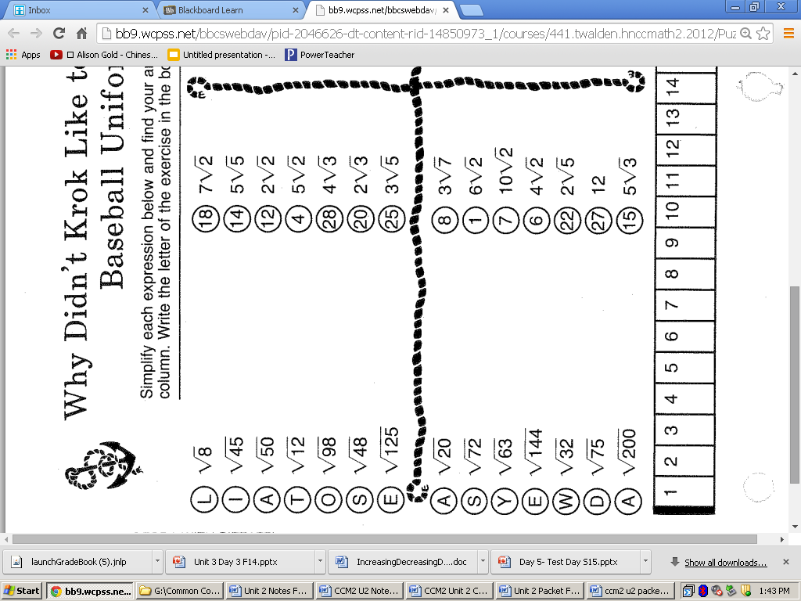**Hint:** If you’re stuck on this page, look at the HW assigned for the night of the Unit 1 test.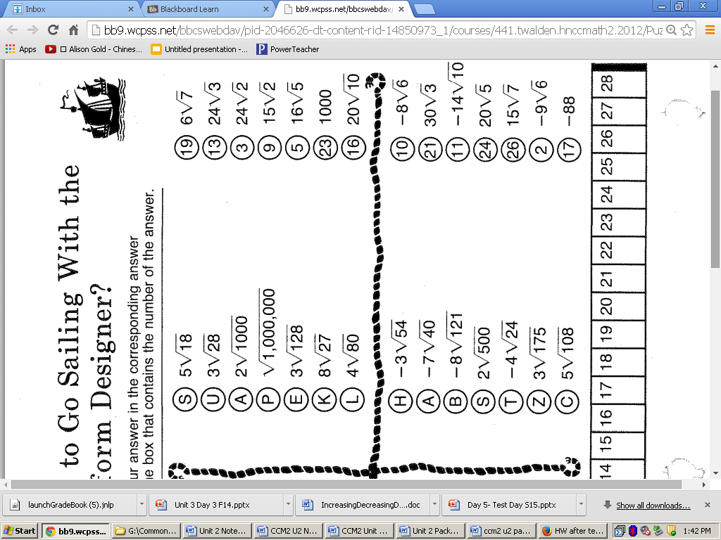

**Day 5 Homework**

Write the equation for a quadratic function that has the following properties:

1. x intercepts at (4.5,0) and (1,0) and y-intercept at (0,9)
2. x intercepts at (7,0) and (1,0) and graph opening upward
3. x intercepts at (0,0) and (6, 0) with a maximum at (3,15)

1. Description: MCj02909280000[1]A town is planning a child care facility. The town wants to fence in a playground

area using one of the walls of the building. What is the largest rectangular   
 playground area that can be fenced in using 100 feet of fencing?

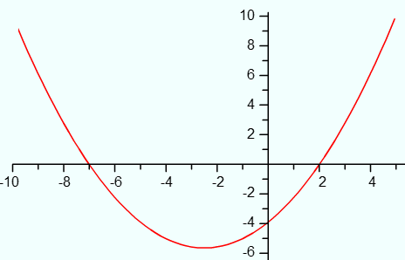

5. Find the equation of the quadratic, in standard form, given the graph and the fact that the graph goes through the point (4.5, 8). Show all you work for writing the equation by hand.

1. An electronics company has a new line of portable radios with CD players. Their research suggests that the daily sales s for the new product can be modeled by s = -p2 + 120p + 1400, where p is the price of each unit.
   1. Find the vertex of the function.
   2. What is the maximum daily sales total for the new product?
   3. What price should the company charge to make this profit?

**Day 6 Homework**

**Comparisons of quadratics in different forms**

1. Three surveyors are having a discussion about bridges in New York City. The first surveyor collected data from the Verrazano Bridge, he measured the height of the cable as he drove from one end to the other. The second surveyor took a picture of the cable for the Brooklyn Bridge. The last surveyor came up with an equation to model the cable height of the Tappan Zee Bridge.

**Brooklyn Bridge**



**Verrazano Bridge**

|  |  |
| --- | --- |
| Horizontal Distance (x) | Height of Cable (y) |
| 0 | 160 |
| 100 | 114.4 |
| 200 | 77.6 |
| 300 | 49.6 |
| 400 | 30.4 |
| 500 | 20 |

**Tappan Zee Bridge**

y = 0.00025x2 - 0.2x + 100

1. Using the information, determine the length of each bridge to decide which one is longest and shortest.
2. Which bridge’s cable gets the closest to the road? How do you know this?
3. One side of a rectangular garden is 2 yd less than the other side. The area of the garden is 63 yd2. Find the dimensions of the garden.

3. The baseball team has decided to have a throwing contest. Below is the data for 3 different players.

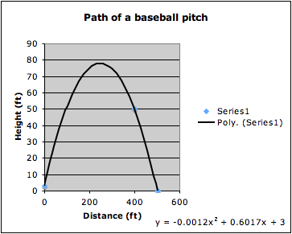**Michael: y = -16x2 + 50x + 5**

**Joe Henry**

|  |  |
| --- | --- |
| **Time (x)** | **Height (y)** |
| **.5** | **37.5** |
| **1** | **63** |
| **2** | **90** |
| **3** | **85** |

0 1 2 3  
 **Time (seconds)**

1. Whose ball was in the air the longest?
2. Who threw their ball the highest?
3. If you were to determine the winner of the contest, who would you choose and why?

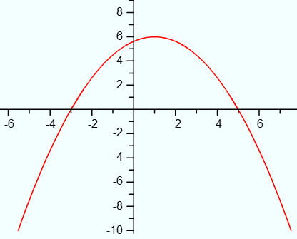

1. Find the equation, in standard form, of the quadratic given the graph with a vertex of (1, 6). Show all your work for writing the equation by hand.

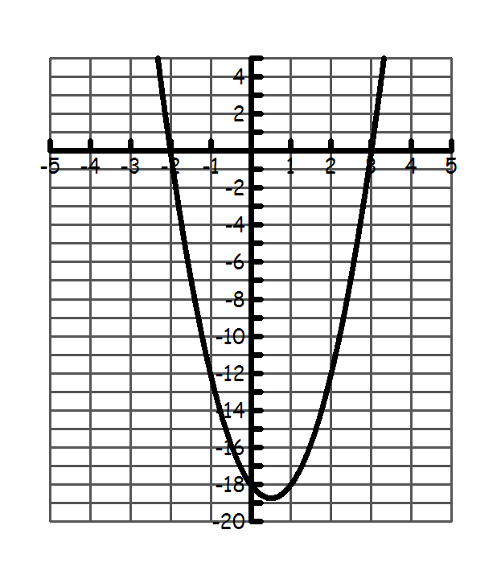

1. Find the equation of the quadratic in standard form. Show all your work for writing the equation by hand.